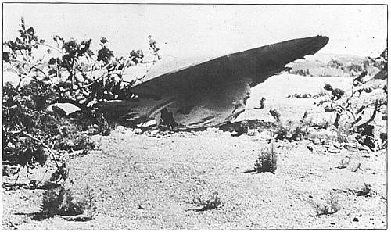
A. Conversation Questions: Aliens

- Do you think that aliens exist?
- If an alien wanted to take you on a vacation to their home would you go?
- What would you do if an alien beamed you up into its ship?
- Should people on Earth try to contact aliens?
- What could be a positive side of discovering life on other planets?
- What could be a negative side of discovering life on other planets?
- If a friend of yours told you that they saw a UFO would you believe them?
- If you saw a UFO would you tell anyone?
- Do you think that aliens are already here on Earth?
- Do believe that there is some kind of life on other planets?

B. HELLO ALIEN: What would you ask an alien if you met one in your local coffee shop? With your partner, write some questions you would like to ask the alien. Take turns in being the alien and answering the questions. Change partners and answer your new partner’s questions.

1. _________________________________________________________________
2. _________________________________________________________________
3. _________________________________________________________________
4. _________________________________________________________________
5. _________________________________________________________________
C. ALIENS : HOW THEY MIGHT LOOK Watch the slideshow with your class and then draw what you think an alien might look like.

D. Listening Quiz: Do you believe in UFOs?

You will hear John and Sue talking about UFOs and whether or not they believe in them. You will hear the selection twice. Choose the correct answer from the multiple choice answers.

- How did Sue hear about the UFOs yesterday?
  - on the TV B) on the radio C) in the newspaper

- Who believes in UFOs?
  - John B) Sue C) Neither

- What does John believe about UFOs?
  - They are likely B) They are fictional C) They are improbable

- What does John first think Sue was when she saw the UFO?
  - She was drunk B) She was ill C) She was hallucinating

- What was Sue doing when she saw the UFO?
  - she was playing in the yard B) she was riding on a bus C) she was walking to school

- What shape was the UFO in?
  - a saucer B) a silver airplane C) a cigar

- Why does Sue think that it couldn't have been an airplane?
  - It was shaped like a saucer B) It was hoovering C) it was moving sidewards

- What does Sue think the UFO might have been?
  - a helicopter B) a bright light C) a weather balloon

- Who did Sue tell?
  - her parentsB) her classmates C) She isn't sure

- Why does Sue think the people in a UFO are like?
  - aggressive B) little and green C) nervous

- What does Sue think might be a reason for the aliens be hostile?
  - If they were frightened B) If we attacked them C) If we were frightened of them

- What proof does Sue provide that UFOs exist?
  - An army general has seen them B) They've been seen by ordinary people C) There is a lot of evidence

- What might convince John that UFOs exist?
  - more evidence B) If he saw one C) If Sue saw another one

http://www.telegraph.co.uk/news/picturegalleries/howaboutthat/8173416/Aliens-How-they-might-look.html?image=1
http://esl.about.com/library/listening/blufo1.htm

