FR 12 – Mme Levin NOM:
L’heure de génie Check-In
Please complete the following check-in. This is NOT for marks, but a chance for me to see how your project is going for you and ways that I can help.

Project:
- What is the topic of your project?

- What is your guiding question?

- On the scale, show how far would you consider yourself in terms of being able to answer the question (1-10)?
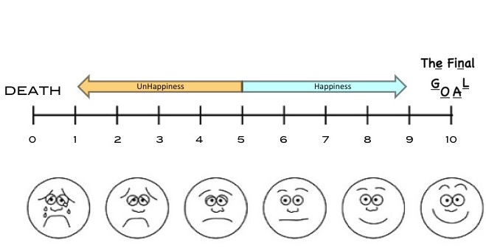
- Using the questions A-D (see below), how do you score out of 16?

_______ / 16

- What have you done so far?

- What are you planning on doing next?

- What are you liking the most about working on your project?

- What are you liking the least?

- What can I do (if anything) to help you best complete this project?

A. Project: Have you answered your question in-depth? Are you demonstrating creativity and originality? Do you have records of you going through (mistakes and all) various stages in the course of completing the project?
Looking for: evidence of the project at different stages of development, and an overall thoughtful reflection on the process. Depending on the project, the evidence could be files, diagrams, sketches, drafts, photos, journal entries etc.

Rate yourself: Not Yet Meeting (1) Minimally Meeting (2) Mostly Meeting (3) Fully Meeting (4)

B. Written: Have you thought about what the written component of your project will be? Do you feel confident you can include at least 10 musique mercredi words (keeping in mind that we are only half-way through our presenters)?
Looking for: written material that demonstrates understanding of grade 12-level grammar. Depending on the project, the written part could be blogs, journal entries, a reflection, instruction manual etc.

Rate yourself: Not Yet Meeting (1) Minimally Meeting (2) Mostly Meeting (3) Fully Meeting (4)

C. Visuals: Have you thought about what kind of visuals you will include to make your project more engaging when students come around to talk to you about it?
Looking for: visuals that draws an audience to talk to you about your project. Depending on the project, the visual part could be pictures, physical demonstrations, final products, sketches etc.

Rate yourself: Not Yet Meeting (1) Minimally Meeting (2) Mostly Meeting (3) Fully Meeting (4)

D. Oral: Have you thought about you will say to students when they come around to talk to you?
Looking for: confident, understandable, unprompted speech and the ability to answer questions. Depending on the project, the oral part could be demonstrations, an explanation of the project, walking students through a process etc. It will most definitely include answering questions (and asking good questions to other students).

Rate yourself: Not Yet Meeting (1) Minimally Meeting (2) Mostly Meeting (3) Fully Meeting (4)

