Listening Project – Resource Portfolio
Some important learning outcomes in our class are that you are able to ‘independently locate, explore and think critically about a wide variety of texts’. Moreover, you should be able to ‘recognize different purposes, degrees of formality, and cultural points of view in these texts’. Often we view ‘texts’ as being only written, but they can be listened to as well! Therefore, this assignment is designed to encourage you to explore and evaluate a variety of listening resources in a subject you want to know more about.

Part one of the assignment is a Listening Resource Portfolio that will be shared with other classes. Eventually, we will build up a list of resources on a variety of subjects with which students can use to practice their listening skills. Part two of the assignment is a Personal Reflection, which will not be shared, that demonstrates your ability to reflect metacognitively (thinking about your thinking) about your listening experiences.

Part One: Resource Portfolio
You will need to find and evaluate four listening resources for your portfolio and submit a copy of what it is, where someone could find it, and whether they should seek it out.
Title:
An image
Author/Source:
Location:
Type:
Description: (3-5 sentences)
Recommendation: 1 to 5 (5 – Highly recommended; I would listen to this even if it wasn’t part of an assignment; 1 – I could barely finish it; I would recommend this only to my worst enemy)

For example, if my theme for this project is ‘Fairy Tales’ I would explore a variety of resource related to my topic. For example:
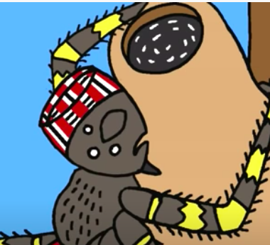
Title Anansi Tries To Steal All the Wisdom in the World
Author/Source: Speakaboos.com
Location: https://www.youtube.com/watch?v=zG9eknk6mqw
Type: Subtitles in English (cat.4)
Description: Nick Cannon reads this tale from West Africa about Anansi the spider who tries to steal all the wisdom in the world. I liked listening to Nick Cannon read, the subtitles were helpful, and the images added to the story. I’ve heard more detailed versions of this particular tale, but this one was pretty great.
Recommendation: ★★★★

In order to encourage you to find a variety of resources, you will use the following table to guide your search. You can either keep your research limited to one aspect (going vertically down only one column) or you can broaden your resources to variety of different aspects (going horizontally, picking one from four of the six columns).

For example, if my theme is ‘Fairy Tales’ I could choose to find listening resources vertically from column 5 (an Asian, South American, African, and European resource) or I could pick horizontally (one resource from each category, such as a resource for children for column 1, a song from column 2, a podcast from column 3, and an African resource from column 5).

Many of the things you find will fit more than one category. That’s okay! Just choose one.

1 | 2 | 3 | 4 | 5 | 6
Audience | Genre | Format | Aids | Continent of Origin | American Region of Origin
Children/Youth | Fiction | A video  (<15 minutes) | Subtitles / transcripts in your L1 | Asia | The North
Second-language learners | Song | A film  (>15 minutes) | Subtitles / transcripts in English | South America | The South
Native speakers | Non-fiction – an interview | Radio (or rebroadcast online) | Slowed pace | Africa | The West
Academics | Non-fiction – informational | Podcast | Images | Europe | The Midland Cities

Not Yet Meeting Expectations | Meeting Expectations
- Less than 4 resources are submitted  - Information is not written in English  - Resources do not vary horizontally or stick to one vertical category  - Resources are not unified under the same theme Includes 6 or fewer criteria for each resource. | - Portfolio includes 4 resources  - Information is written in English  - Resources are chosen from different horizontal categories or from one vertical category  - Resources are unified under the same theme Includes the 7 criteria for each resource.
Resource Portfolio Criteria:

- Author/Source
- Description (3-5 sentences)
- Title
- Location
- Recommandation
- Type
- An image

Part Two: Personal Reflection

You will answer all questions below. Your reflection should be between 500-1000 words. You will be evaluated on the depth of your reflection, the connections you make, your metacognition (thinking about your thinking), and the evidence you use to support your points.

Content Reflection

- What differences and commonalities did you notice across the different resources? Give examples.
- What were your preferred and least-preferred resources? Explain why.

Skill Reflection

- What strategies did you attempt in order to maximize your comprehension? How successful were they?
- If you were going to create an original listening resource for our class, how would you structure it? What would you include to ensure maximum comprehension and why?

Not Yet Meeting (I) | Minimally Meeting (C) | Mostly Meeting (B) | Fully Meeting (A)
Information presented has no amount of evidence from their four resources to support it.  Student does not demonstrate that they have reflected on their own language learning. | Information presented has a minimal amount of evidence from their four resources to support it.  Student demonstrates that they have reflected minimally on their own language learning. | Information presented has a good amount of evidence from their four resources to support it.  Student demonstrates that they have reflected broadly on their own language learning. | Information presented has an excellent amount of evidence from their four resources to support it.  Student demonstrates that they have reflected deeply on their own language learning.

You will hand-in your Resource Portfolio (without your name or any identifying information) along with your Personal Reflection (which will have your name and a word count) on:

Theme: Fairy Tales

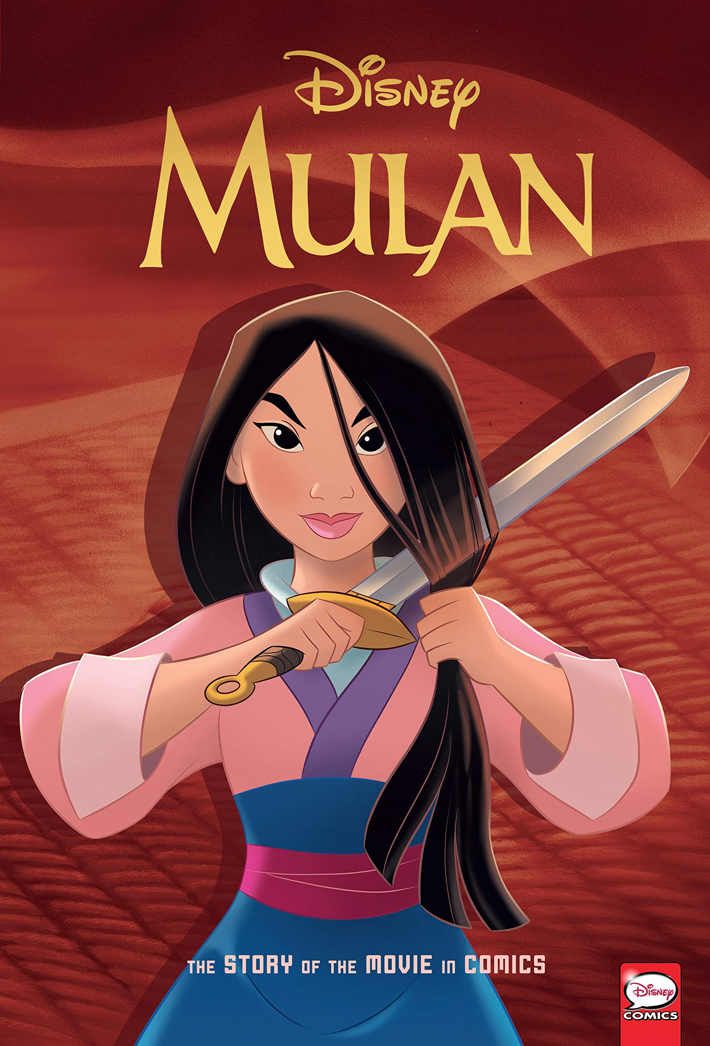
Le titre: Mulan
Auteur/Source: Disney
Location: Disney+
Type: For children (cat.1)
Description: This movie is an adaptation of a Chinese fairy tale. It’s really funny and has catchy songs! My favorite was ‘I’ll Make a Man Out of You’. I didn’t get all of the jokes and I watched with my little sister who was scared at some parts, so I’m only giving it four stars.
Recommendation: ★ ★ ★ ★

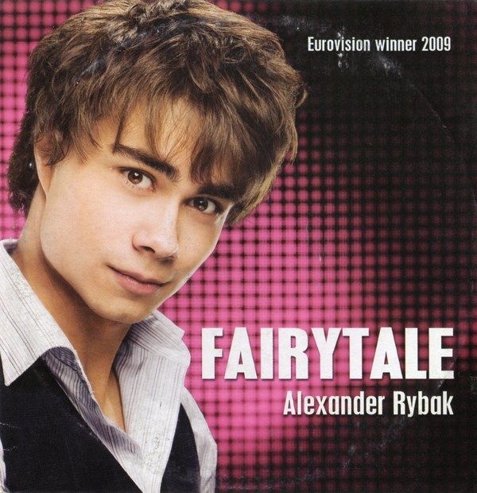
Title: Fairy Tale
Author/Source: Alexander Rybak
Location: https://www.youtube.com/watch?v=jtj3k_thBE4
Type: Song (cat.2)
Description: This song won Eurovision in 2009 and is about a boy who is in love with a girl but realizes it’s a “fairy tale”. The violin is unusual but really catchy, and I agree with 600,000 voters that this is a great song! My favorite comment on the YouTube video is someone who wrote: “He literally looks like he wouldn’t hurt a fly but this song is the song that plays when you find the villain isn’t actually dead”
Recommendation: ★ ★ ★ ★ ★

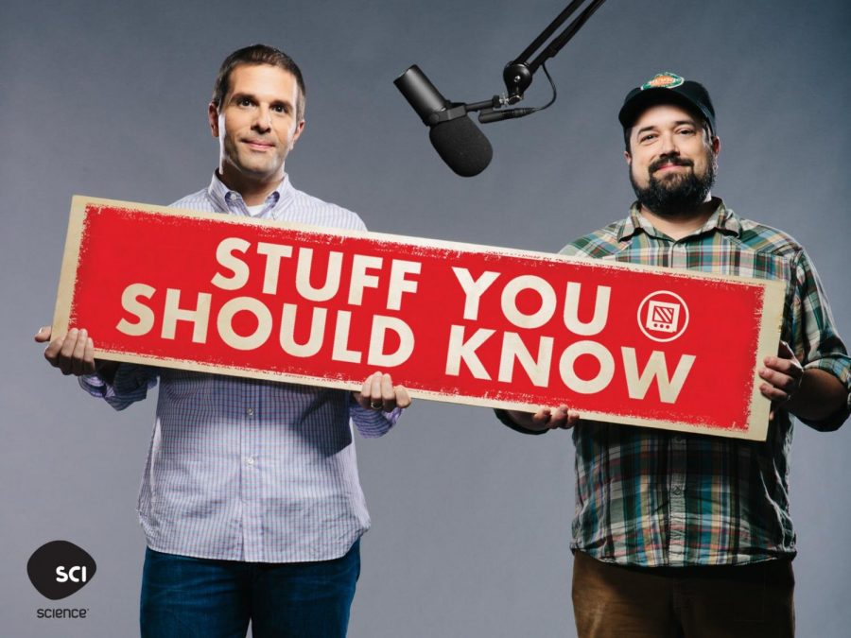
Title: The Dark Origins of Fairy Tales
Author/Source: Stuff You Should Know Podcast
Location: https://www.iheart.com/podcast/105-stuff-you-should-know-26940277/episode/the-dark-origins-of-fairy-tales-29467529/
Type: Podcast (cat.3)
Description: This podcast was really long (47 minutes) though I learned a lot about the origin of fairy tales. I couldn’t follow everything they said because they talked so fast, and I didn’t understand all the references. However, both hosts made this more interesting than academic.
Recommendation: ★ ★ ★

Title: Anansi Tries To Steal All the Wisdom in the World
Author/Source: Speakaboos.com
Location: https://www.youtube.com/watch?v=zG9eknk6mqw
Type: Subtitles in English (cat.4)
Description: Nick Cannon reads this tale from West Africa about Anansi the spider who tries to steal all the wisdom in the world. I liked listening to Nick Cannon read, the subtitles were helpful, and the images added to the story. I’ve heard more detailed versions of this particular tale, but this one was pretty great.
Recommendation: ★ ★ ★ ★

Theme: ____________________________________________________________________

DRAFT
Title:

Author/Source:
Location:
Type:
Description:

Recommendation:

Title:

Author/Source:
Location:
Type:
Description:

Recommendation:

Title:

Author/Source:
DRAFT
Location:
Type:
Description:

Recommendation:

Title:

Author/Source:
Location:
Type:
Description:

Not Yet Meeting Expectations | Meeting Expectations
- Less than 4 resources are submitted  - Information is written in English  - Resources do not vary horizontally or stick to one vertical category  - Resources are not unified under the same theme  - Includes 6 or fewer criteria for each resource. | - Portfolio includes 4 resources  - Information is written in French  - Resources are chosen from different horizontal categories or from one vertical category  - Resources are unified under the same theme  - Includes the 7 criteria for each resource.
Recommendation:

