Une tâche d’écoute – Un portefeuille des ressources
Some important learning outcomes in French 12 are that you are able to ‘independently locate, explore and think critically about a wide variety of texts’. Moreover, you should be able to ‘recognize different purposes, degrees of formality, and cultural points of view in these texts’. Often we view ‘texts’ as being only written, but they can be listened to as well! Therefore, this assignment is designed to encourage you to explore and evaluate a variety of listening resources. Additionally, it is designed to dovetail with the research component of your Genius Hour project.

Part one of the assignment is a Listening Resource Portfolio that will be shared with other French classes. Eventually, we will build up a list of resources on a variety of subjects with which students can use to practice their listening skills. Part two of the assignment is a Personal Reflection, which will not be shared, that demonstrates your ability to reflect metacognitively (thinking about your thinking) about your listening experiences.

Part One: Resource Portfolio
You will need to find and evaluate four listening resources for your portfolio and submit a hard copy of what it is, where someone could find it, and whether they should seek it out.
Le titre:
Auteur/Source:
Une image
Location:
Type:
Description: (3-5 phrases)
Recommandation: 1 à 5 (5 – Highly recommended: I would listen to this even if it wasn’t part of an assignment; 1 – I could barely finish it: I would recommend this only to my worst enemy)

For example, if my genius hour question is “Qu’est-ce que je peux apprendre de moi-même et le monde avec les contes?” I would explore a variety of resource related to my topic. For example:
Le titre: Contes traditionnels africains
Auteur/Source: Bibliboom.com
Location: http://www.bibliboom.com/pages/titres/contes-traditionnels-africains-livre-audio-gratuit-bibliboom-telecharger-format-mp3.html
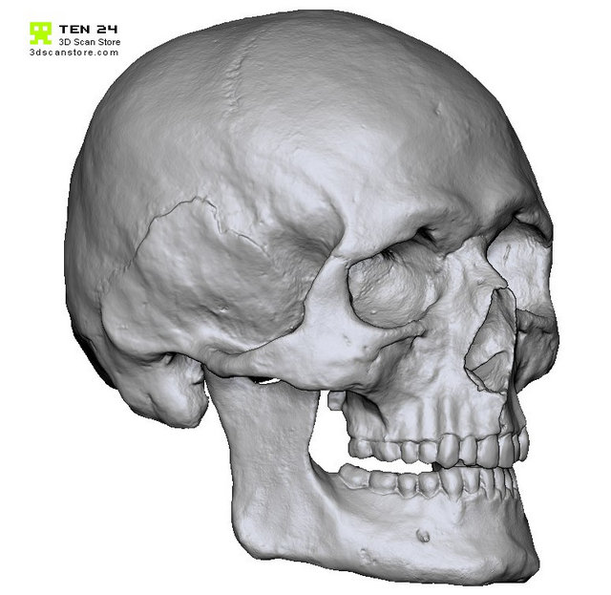
Type: L’origine africaine (cat.5)
Description: La lectrice (s’appelle ‘Pomme’) parle lentement et clairement. Alors, je comprends beaucoup de quoi elle dit. Des trois contes traditionnels africains (Ingratitude, La Parole et Un Œil – chaque 3-4 minutes) je préfère le deuxième parce qu’il y a un jeune homme qui trouve un crâne qui parle, mais seulement pour lui! Ce conte me fait penser au dessin animé avec la grenouille parlante.
Recommandation: ★ ★ ★ 
In order to encourage you to find a variety of resources, you will use the following table to guide your search. You can either keep your research limited to one aspect (going vertically down only one column) or you can broaden your resources to variety of different aspects (going horizontally, picking one from four of the six columns). For example, if my genius hour question is “Qu’est-ce que je peux apprendre de moi-même et le monde avec les contes?” I could choose to find listening resources vertically from column 5 (an Asian, South American, African, and European resource) or I could pick horizontally (a resource for children for column 1, a song from column 2, a podcast from column 3, and an African resource from column 5). Many of the things you find will fit more than one category. That’s okay! Just choose one.

1 | 2 | 3 | 4 | 5 | 6
L’Audience | Le Genre | Le Format | Les Aides | Continent d’Origine | Origine Canadienne
Les enfants / Les adolescents  (Children/Youth) | Fiction | Une vidéo  (<15 minutes) | Les sous-titres anglais (Subtitles / transcripts in English) | Asie (ex. Vietnam, Laos, etc.) | Acadien (Nouveau-Brunswick)
Français Langue Étrangère (Second-language learner) | Une chanson (Song) | Un film  (>15 minutes) | Les sous-titres françaises  (Subtitles / transcripts in French) | Amérique du Sud / Caraïbe (ex. Haiti, French Guiana, etc.) | Métis & Autochtone (Manitoba/ Saskatchewan)
Une personne de langue maternelle/natale (Native speaker) | Non-fiction – une entrevue | La radio (or rebroadcast online) | La vitesse lente (Slowed pace) | Afrique (ex. Ivory Coast, Gabon, etc.) | Québécois (Quebec)
Scolaire (Academic) | Non-fiction – informationnel | Baladodiffusion (Podcast) | Des images | Europe (ex. France, Belgium, etc.) | Des autres provinces

Not Yet Meeting Expectations | Meeting Expectations
- Less than 4 resources are submitted  - Information is written in English  - Resources do not vary horizontally or stick to one vertical category  - Resources are not unified under the same theme or question  - Includes 6 or fewer criteria for each resource. | - Portfolio includes 4 resources  - Information is written in French  - Resources are chosen from different horizontal categories or from one vertical category  - Resources are unified under the same theme or question  - Includes the 7 criteria for each resource.
Resource Portfolio Criteria:

- Auteur/Source
- Description (3-5 phrases)
- Le titre
- Location
- Recommandation
- Type
- Une image

Part Two: Personal Reflection

You will answer all questions below in English. Your reflection should be between 500-1000 words. You will be evaluated on the depth of your reflection, the connections you make, your metacognition (thinking about your thinking), and the evidence you use to support your points.

Content Reflection

- What differences and commonalities did you notice across the different resources? Give examples.
- What were your preferred and least-preferred resources? Explain why.

Skill Reflection

- What strategies did you attempt in order to maximize your comprehension? How successful were they?
- If you were going to create an original listening resource for our class, how would you structure it? What would you include to ensure maximum comprehension and why?

Not Yet Meeting (I) | Minimally Meeting (C) | Mostly Meeting (B) | Fully Meeting (A)
Information presented has no amount of evidence from their four resources to support it.  Student does not demonstrate that they have reflected on their own language learning. | Information presented has a minimal amount of evidence from their four resources to support it.  Student demonstrates that they have reflected minimally on their own language learning. | Information presented has a good amount of evidence from their four resources to support it.  Student demonstrates that they have reflected broadly on their own language learning. | Information presented has an excellent amount of evidence from their four resources to support it.  Student demonstrates that they have reflected deeply on their own language learning.

You will hand-in your Resource Portfolio (without your name or any identifying information) along with your Personal Reflection (which will have your name and a word count) on:
Thème: Les Contes de Fées
Ma question: Qu’est-ce que je peux apprendre de moi-même et le monde avec les contes?

Le titre: Cendrillon
Auteur/Source: Les P'tits z'Amis
Location: www.youtube.com/watch?v=soE3pxa8wMM
Type: Pour les enfants (cat.1)
Description: Une vidéo de 7:29 qui raconte l’histoire traditionnelle de Cendrillon. Les sous-titres sont en français et sont plus sophistiqués que les paroles (aussi en français). Les images sont adorables et aident l’écouteur pour comprendre l’histoire.
Recommandation: ★ ★ ★ ★

Le titre: Cendrillon
Auteur/Source: Matthieu Mendès
Location: www.youtube.com/watch?v=M4s5QcdVlyE
Type: Une chanson (cat.2)
Description: Cette chanson est très accrocheuse et je peux l’écouter toute la journée! Matthieu Mendès raconte l’histoire moderne de Cendrillon : le prince était sorti et elle est devenue un junkie! Cette chanson nous fait réfléchir à ce qui se passe après « ils vécurent heureux et eurent beaucoup d’enfants ».
Recommandation: ★ ★ ★ ★ ★
Le titre: La planète des contes : De l’homme et de la femme, qui l’emporte?
Auteur/Source: Jean Lebrun
Location: www.franceinter.fr/emissions/la-marche-de-l-histoire/la-marche-de-l-histoire-27-decembre-2013
Type: Baladodiffusion (cat.3)
Description: Cette baladodiffusion est très académique, et plus vite et sèche que j’aimerais. La grande question que Jean Lebrun demande est, ‘de l’homme et de la femme, qui l’emporte dans les contes ?’ À la fin, il n’y a pas une réponse exacte, mais plusieurs avis différents qui changeaient pendants les années.
Recommandation: ★ ★ 

Le titre: Contes traditionnels africains
Auteur/Source: Bibliboom.com
Location: http://www.bibliboom.com/pages/titres/contes-traditionnels-africains-livre-audio-gratuit-bibliboom-telecharger-format-mp3.html
Type: L’origine africaine (cat.5)
Description: La lectrice (s’appelle ‘Pomme’) parle lentement et clairement. Alors, je comprends beaucoup de quoi elle dit. Des trois contes traditionnels africains (Ingratitude, La Parole et Un Œil – chaque 3-4 minutes) je préfère le deuxième parce qu’il y a un jeune homme qui trouve un crâne qui parle, mais seulement pour lui! Ce conte me fait penser au dessin animé avec la grenouille parlante.
Recommandation: ★ ★ ★ 

Thème: ____________________________________________________________________

Question: __________________________________________________________________

BROUILLON
Le titre:

Auteur/Source:
Location:
Type:
Description:

Recommandation:

Le titre:

Auteur/Source:
Location:
Type:
Description:

Recommandation:

Le titre:
BROUILLON
Auteur/Source:
Location:
Type:
Description:

Recommandation:

Le titre:

Auteur/Source:
Location:
Type:
Description:

Not Yet Meeting Expectations | Meeting Expectations
- Less than 4 resources are submitted  - Information is written in English  - Resources do not vary horizontally or stick to one vertical category  - Resources are not unified under the same theme or question  - Includes 6 or fewer criteria for each resource. | - Portfolio includes 4 resources  - Information is written in French  - Resources are chosen from different horizontal categories or from one vertical category  - Resources are unified under the same theme or question  - Includes the 7 criteria for each resource.
Recommandation:

