Math: Percentages with the Census
Info source: www.census.gov/newsroom/facts-for-features/2021/womens-history-month.html
Every ten years the United States government takes a census, which is a survey of all the people who live in America. They collect information about many things, including how many people identify as female or male. We’re going to use these numbers to practice finding percentages.

Question One: In 2019, there were 167 million females and 162 million males. What percentage of the population was female and what percentage was male?

Let’s do the first part together:
Step One: Determine the total 167 + 162 = 329 million
Step Two: Divide the number you want the percentage of 167 / 329 = 0.508
Step Three: Multiply the value by 100 0.508 x 100 = 50.8
Therefore, the US population in 2010 was 50.8% (or we can round to 51%) female.

Now it’s your turn:
Step One: Determine the total 167 + 162 = 329 million
Step Two: Divide the number you want the percentage of 162 / 329 = 0._______
Step Three: Multiply the value by 100 0._______ x 100 = ________

Therefore, the US population in 2010 was _______% male.

Question Two: In 2010 there were 157 million females and 152 million males. What percentage increase in females and males did the US have between 2010 and 2019?

Let’s do the first part together:
Step One: Subtract the old number from the new number 167 - 157 = 10
Step Two: Divide the difference by the old number 10 / 157 = 0.06
Step Three: Multiply the value by 100 0.06 x 100 = 6
Therefore, the population of females increased by 6% between 2010 and 2019.

Now it’s your turn:
Step One: Subtract the old number from the new number _____ - _____ = 10
Step Two: Divide the difference by the old number 10 / _____ = _____
Step Three: Multiply the value by 100 _____ x 100 = _____

Therefore, the population of males increased by _____% between 2010 and 2019.

Math: Reading an Infographic
Info source: www.census.gov/newsroom/facts-for-features/2021/womens-history-month.html

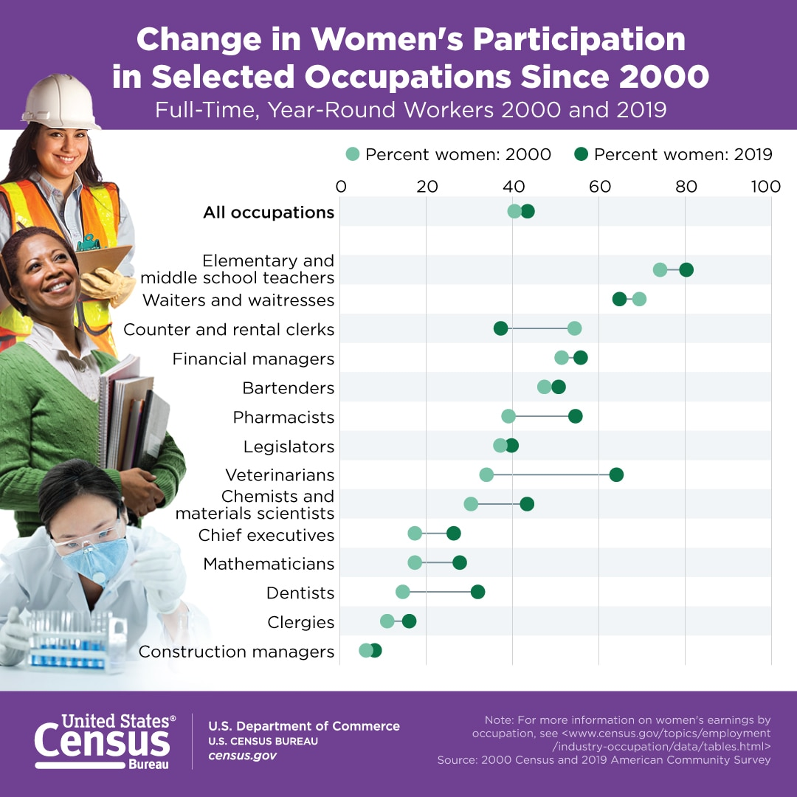
Use the infographic to answer the following questions:

- What are the two occupations where women’s participation decreased between 2000-2019?

- What are the two occupations where women’s participation increased the least between 2000-2019?

- What is the occupation where women’s participation increased the most between 2000-2019?

Discussion: Why do we keep track of these percentages? What can these numbers tell us about our society?

