Math: Reading an Infographic
Info source: www.census.gov/newsroom/facts-for-features/2021/womens-history-month.html

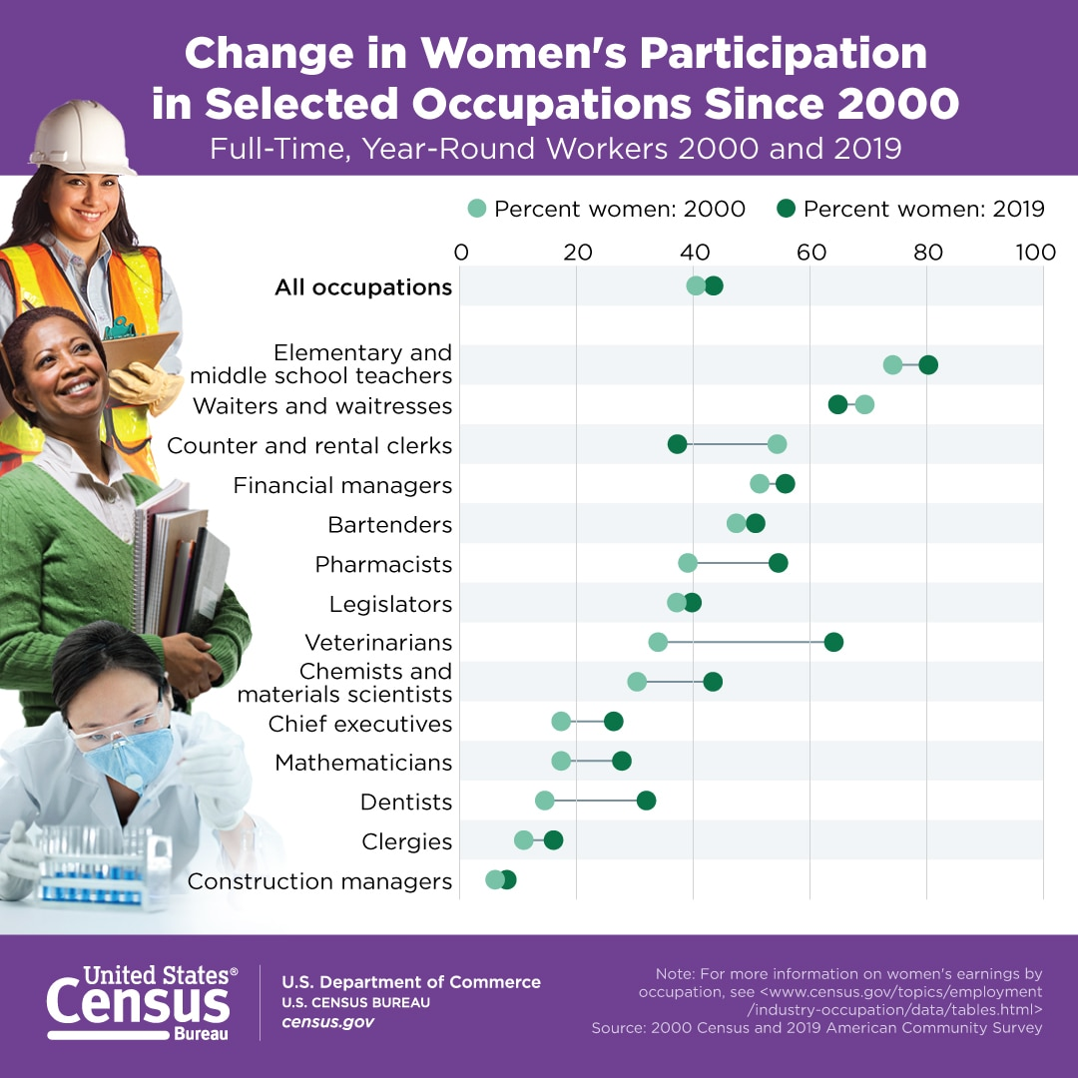
Use the infographic to answer the following questions:

- What are the two occupations where women’s participation decreased between 2000-2019?

- What are the two occupations where women’s participation increased the least between 2000-2019?

- What is the occupation where women’s participation increased the most between 2000-2019?

Discussion: Why do we keep track of these percentages? What can these numbers tell us about our society?

